**Login Credentials**

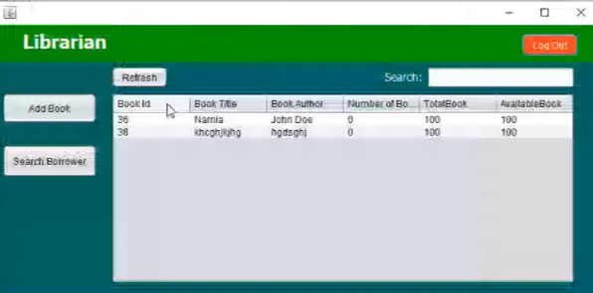

**Login as admin:**

**Username: Admin**

**Password: Admin**